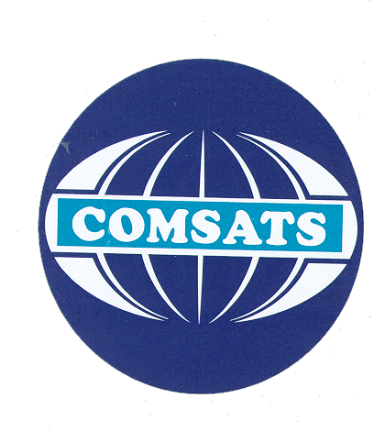
COMSATS Institute of Information Technology
Abbottabad

Course Plan – Semester Fall 2013.
Course Code: Phy121

Total Credit Hours: 4 Lectures Credit Hours: 3 Lab. Credit Hours: 1

Total Contact Hours: 6 Lecture Contact Hours: 3 Lab. Contact Hours: 3

Office Hours (Day, time and place):

Pre-Requisite: Students should be familiar with the fundamentals and basic principles of Physics and their applications in daily life.

Course Objectives and Outcomes:

First Part Objectives: This course addresses the basic concepts and the latest developments in different areas of Physics. The focus is on understanding different physical phenomenon and their applications.

Second Part Objectives: This course is organized in a way that it starts with the elementary basic concepts in Physics and then gradually moving to the latest areas like, starting from the Atomic Structure to Electrostatics, Electric conduction in Metals, Semiconductors, Doping, Charge in electric and Magnetic field.

Ultimate Objectives: By the end of the semester, the student should be able to understand the basics of the entire electromagnetic phenomenon and must have developed a good engineering base.

Course Outline and Contents:

Week 1 | General Introduction to the contents of the course, Applications of Physics in different Engineering disciplines, Bohr’s theory of hydrogen atom.
Week 2 | Electric Charge, Electrical Conductors and Insulators. Coulomb’s law for point Charges, Coulomb’s law for the Continuous Charge Distribution.
Week 3 | (A Uniform line of charge & a ring of charge), Exercises/ Problems
Week 4 | Electric field, Electric field of point charges, A Dipole in an Electric Field, Gauss’s Law, Applications of Gauss’s Law (Infinite Line of Charge, Infinite sheet of Charge) Exercises/ Problems
Week 5 | Potential Energy, Electric Potential, Potential due to Point Charges, Potential due to an Electric Dipole, Electric Potential of Continuous Charge Distributions (A Uniform line of charge & a ring of charge), Exercises/ Problems
Week 6 | A conductor in an electric field (Static & Dynamic Conditions), Current Density & Drift velocity. Ohm’s Law & Ohmic Materials, Capacitor and Capacitance, Capacitors in Series and Parallel, Exercises/ Problems
Week 7 | Electric current, emf, Analysis of Circuits, Electric Fields in circuits, Resistances in series & parallel, Exercises/ Problems
Week 8 | Magnetic Interactions & Magnetic Poles, Magnetism & Moving Charges, The magnetic force on a Moving Charge, The Lorentz Force, The Hall Effect, and Magnetic force on a current carrying wire, The Torque on a Current Loop
Week 9 | Magnetic Field due to a Moving Charge, Biot-Savarts law & its applications (A straight wire segment), Two Parallel Currents, The Interaction between Parallel Currents
Week 10 | The Magnetic Field of a Solenoid, Ampere’s Law, Applications of Ampere’s Law (For a Long Straight Wire, a Solenoid.),
Week 11 | Faraday’s Law of Induction, Lenz’s Law, Motional emf, Generators & Motors, Induced Electric Fields,
Week 12 | The Magnetic Dipole, The Force on a Dipole in a Nonuniform Field, Magnetization, Magnetic Materials (Paramagnetism, Diamagnetism, Ferromagnetism), Gauss’ Law for Magnetism
Week 13 | Inductance, Calculating the Inductance, (Self & mutual Induction), The Inductance of a Solenoid, LR Circuits, Energy Storage in a Magnetic Field
Week 14 | Alternating Currents, Three Separate Elements, The Single Loop RLC Circuit, Power in AC Circuits, The Basic Equations of Electromagnetism and Maxwell’s Equations
Week 15 | Electrical conduction in Semiconductors, Intrinsic and Extrinsic Semiconductors, P type and N type materials,
Week 16 | PN junction, Transistors, Common emitter, Common base and Collector Circuits, Field effect Transistors, Super conductors
Week 17 | Presentations
Week 18 | Whole Course Revision
Week 19
Week 20

Assessment Plan (Quizzes, Assignments, Case Studies, Presentations, Practical, Tests etc. With starting and submission dates where applicable):

Week 1 | No assignment
Week 2 | Assignment on Significance of Atomic Structure with respect to different atomic models
Week 3 | Assignment on Coulomb’s Law and Electric Fields
Week 4 | Quiz 1, covering the class teaching by date
Week 5 | Assignment on Electric Potential
Week 6 | Quiz 2, Electrostatics
Week 7 | No assignment
Week 8 | Assignment on Magnetism
Week 9 | Assignment on Application of Ampere’s Law
Week 10 | Quiz 3, Electromagnetism
Week 11 | Assignment on Electromagnetic induction
Week 12 | No Assignment
Week 13 | Assignment on laws of electromagnetism
Week 14 | Quiz 4, Optics principles
Week 15 | Assignment on Interference and Diffraction
Week 16 | Assignment on P and N type materials
Week 17 | Presentation on Electromagnetic theory Group I
Week 18 | Presentation on Electromagnetic theory Group II
Week 19
Week 20

Text Book / Essential Reading:
- Physics, 5-th ed. By Halliday, Resnick and Krane
- Physics A level, by Pacific and Poh Liong Yong

Reference Books / Literature:
- Engineering Electromagnetics by William H Hayt and John A Buck, 6-th ed.
- Physics by Gilbert Rowell and Sydney Herbert, Cambridge ed.

